- System GUI design.

* A screenshot of a blue and white website

  Description automatically generated**Sign up**
* 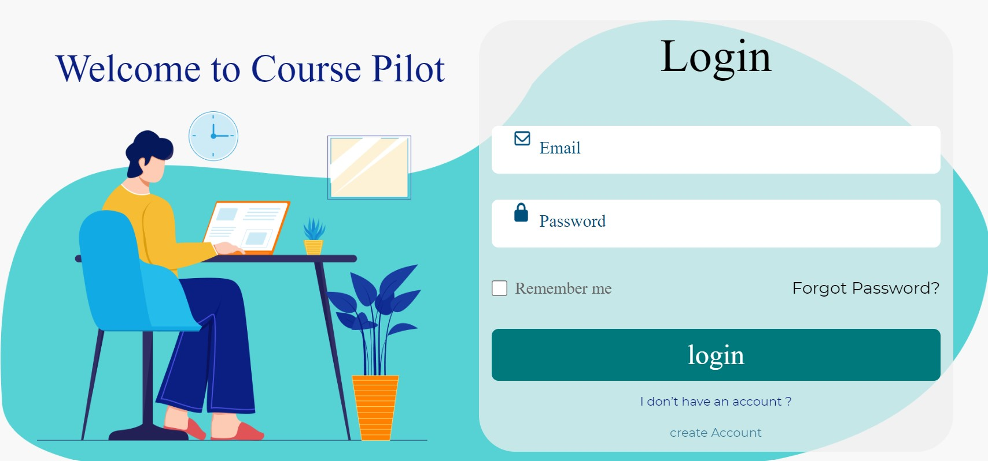**Log in**
* **Home Page**
* 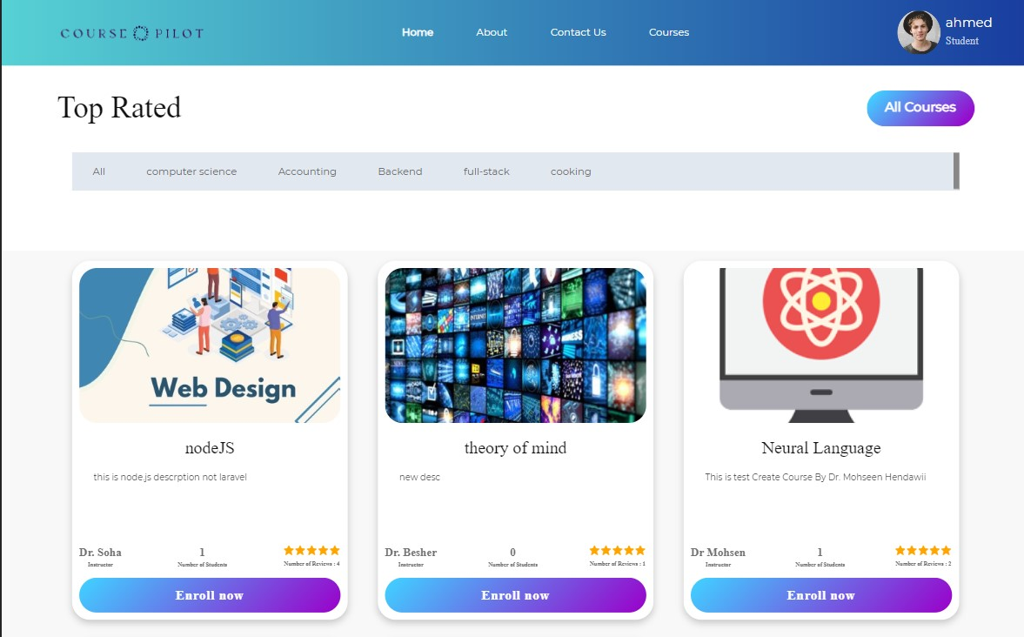**Top Rated (Based of Courses Reviews Analysis)**
* 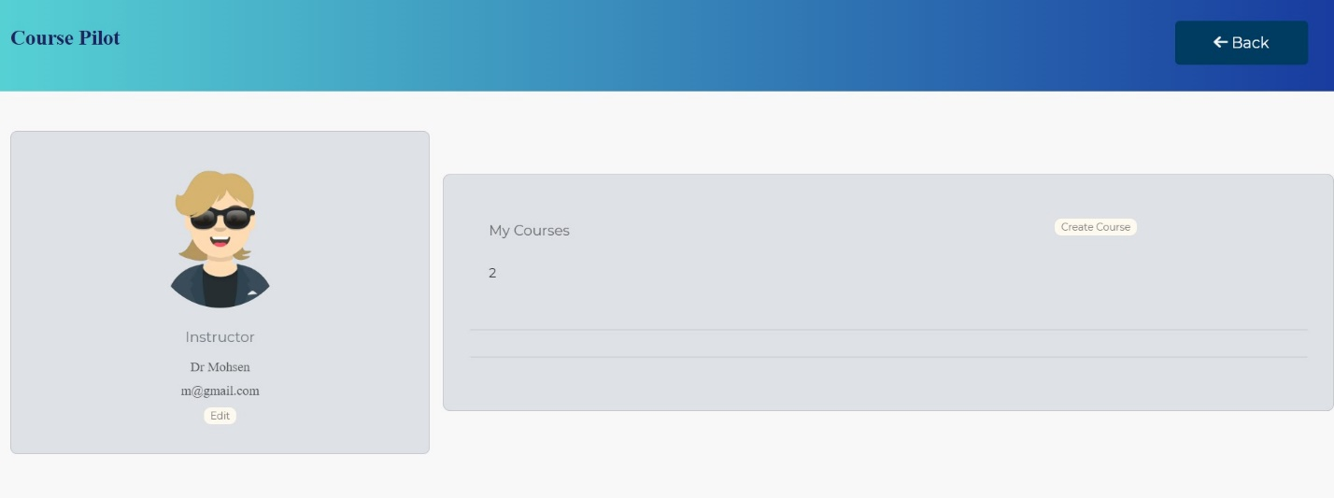**User Profile (Instructor)**
* 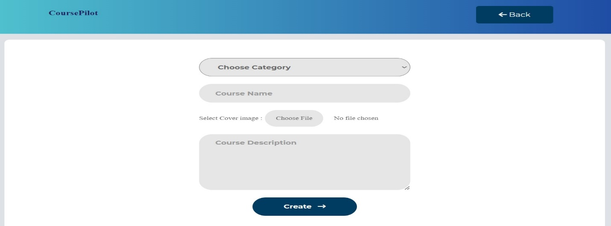**Create Course**
* 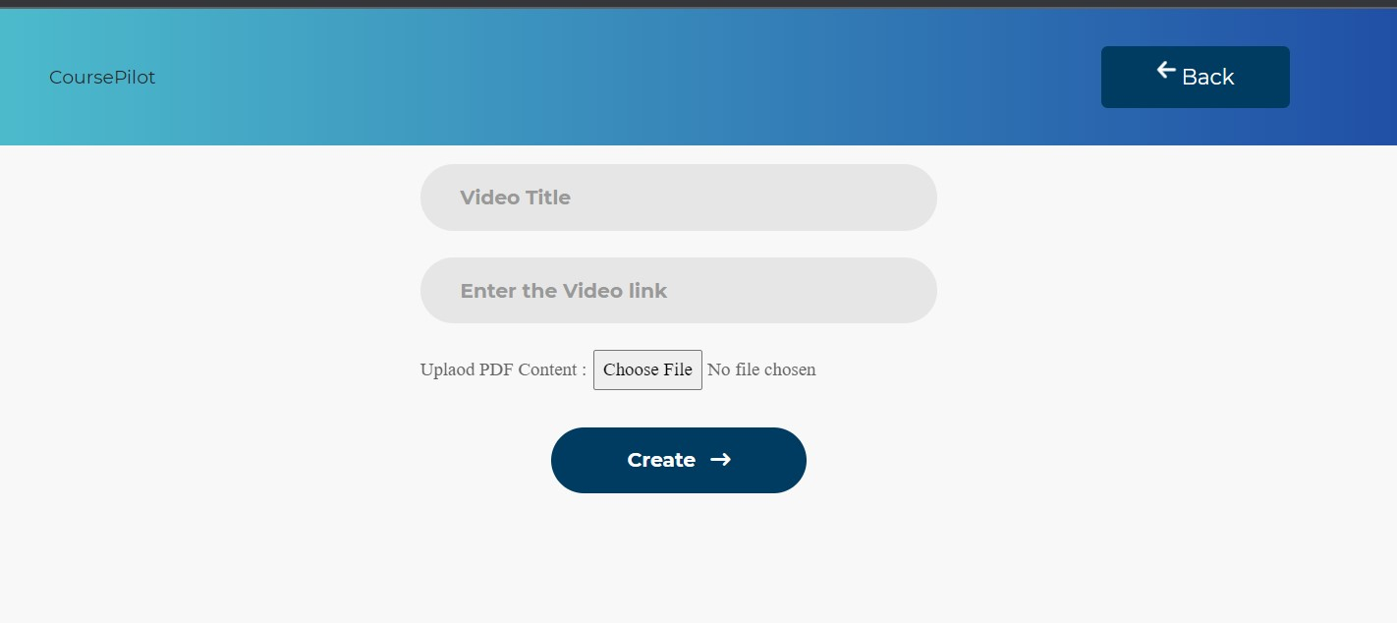**Upload Material in Course**
* 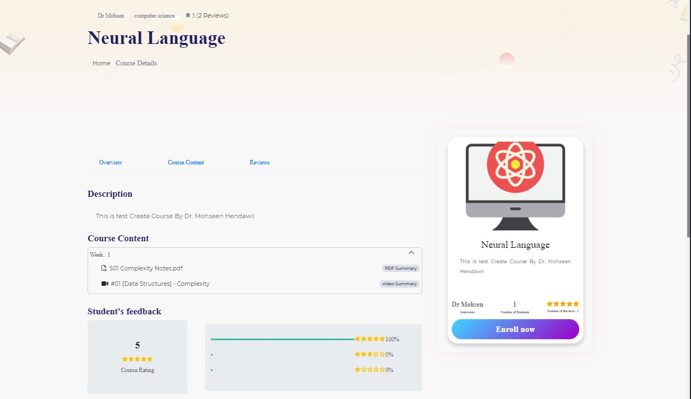**Course Details Page**
* **A screenshot of a chat

  Description automatically generatedWrite Review**